*PostGreSQL User Guide*

Table of Contents

Objective 2

Architecture 2

Norms 2

PostGreSQL Product Lifecycle 4

GDI Support 4

Disaster Recovery and Resiliency (with RTO/RPO) 4

How to create PostGreSQL Database ? 5

Connect to SG Cloud to create a new PostgreSQL VM 5

Select a RHEL7 OS (>= 7.0) in the “Catalog” tab 6

VM General Settings 7

VM sizing (« Machine Configuration ») 8

Post installation of a PostgreSQL envirnonment 9

Get the connection string of your new PostgreSQL Server 9

Create a user on the PostgreSQL Server 9

Create a database on the PostgreSQL Server 9

Setup your PostgreSQL backup policy 9

# Objective

This document describes the installation process of a PostgreSQL environment.

All the following tasks have to be executed by the client (ITEC).

The first part of the document describes the way to create a new VM on SG Cloud and to automatically create the corresponding PostgreSQL Server.

The second part of the document describes the operational process to complete the installation.

# Architecture

All PostgreSQL installations are done on SGCloud (Virtualization)

The physical servers are all located in FRANCE: Primary site (Marcoussis, Paris area) and Secondary/DR site (Seclin, North of France)

## Norms

Each PostgreSQL server is given an internal GTS name.

This name is automatically given by the system while the PostgreSQL server is created.

Ie: PPARADBD093

Type of RDBMS: **P**ostgresql

Location : **PAR**is

Trigram : **ADB**

Env type : **D**evelopment

Env number : **093**

You can find information about your PostgreSQL server on wwwdba (<https://wwwdba/>)

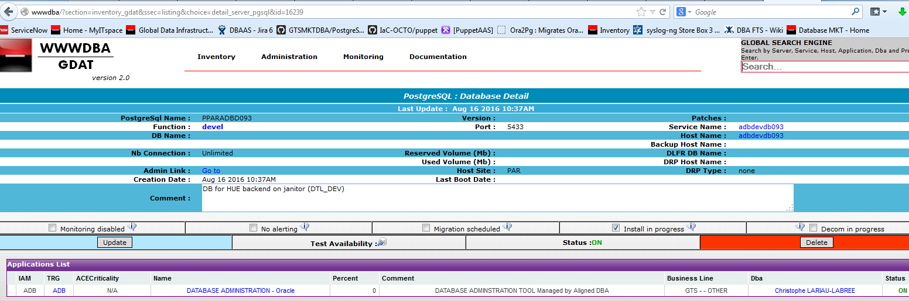

**PostgreSQL binaries**

* Exclusively provided by RedHat (part of Software Collections)
* **Available versions**: 9.5 (the 9.4 version is also available but deprecated)

**Type of environment supported**

* Production / Development

## PostGreSQL Product Lifecycle

* maximum of 3 years lifetime starting from the **Release Date**
* You MUST migrate to a supported versions before the **Retirement Date** of your current PostgreSQL version

<https://access.redhat.com/support/policy/updates/rhscl>

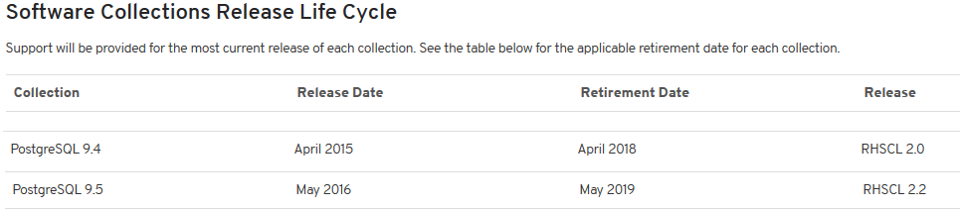

## GDI Support

* **GDI support :**  24H/24 7/7 Days

**To find your Primary/Backup DBA** (<https://wwwdba/>)

**Global Email:** PAR-Resg-Gts-Mkt-Gdi-Postgresql

**Service now ticket**

* **The high level support, bug fix support is provided by redhat:** J+1 5/7

## Disaster Recovery and Resiliency (with RTO/RPO)

GDI PostGreSQL Resiliency is based on SG Cloud Resiliency as detailed below.

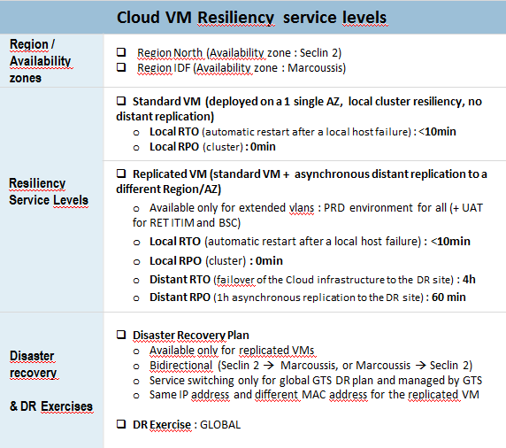

(Picture downloaded from <https://sgcommunities.safe.socgen/wiki/view/pageId/2589/slug/cld-technical-service-catalogue>)

## Backups & dumps

* **VM backups** 
  + You can choose to enable the VM backup while creating your environment
  + No VM backup ⬄ Not possible to restore the PostgreSQL environment in case of destroyed/corrupted VM
  + **It is highly recommended to enable the VM backups on production**
  + **It is not possible to restore a PostgreSQL cluster if the VM backup has been setup but no physical/logical PostgreSQL backup exists**
* **PostgreSQL physical backup**
  + Rely on a physical copy of the entire PostgreSQL Server
  + No way to restore a single database
  + Point in time recovery (restore to a specific date)
  + Can be run while the Cluster is UP (the archive mode must be enabled)
  + Check with your DBA to setup a scheduled physical backup (daily / weekly)
  + **It is highly recommended to enable the VM backups if you setup the PostgreSQL physical backups on production**
* **PostgreSQL logical dump**
  + Rely on pgdump
  + Can restore a PostgreSQL Server, a database, a table
  + No way to do a point in time recovery
  + Can be run while the PostgreSQL cluster is UP (tables cannot be dropped or altered during the backup)
  + Check with your DBA to setup a scheduled physical backup (daily / weekly)
  + **It is highly recommended to enable the VM backups if you setup the PostgreSQL logical backups on production**

# How to create PostGreSQL Database ?

## Connect to SG Cloud to create a new PostgreSQL VM

Url : <http://sgcloud.fr.world.socgen/>



Documentation : <http://sgcloudview/>

(read this documentation if you don’t have credentials or quotas)

## Select a RHEL7 OS (>= 7.0) in the “Catalog” tab

* Select the right Business group
  + Non production server: **BG-GTS-MKT-DBA**
  + Production server : **BG-GTS-MKT-DBA_PRD**

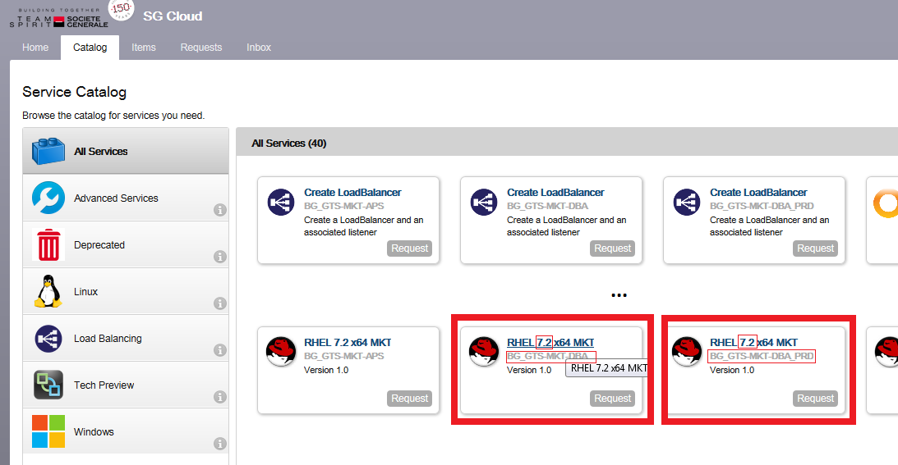

## VM General Settings

* + Choose the good lease date
    - 0 means no lease
    - Be careful with lease time on production (⬄ VM will be automatically trashed)
  + Choose your backup policy if the VM is on production
    - A backup will allow you to restore your environment past in the time and survive a VM corruption/destruction
  + Choose the replication policy if the VM is on production
    - The replication copy your environment to a backup site in case of major failure on the primary site
    - It’s not a backup solution but a high availability solution

## VM sizing (« Machine Configuration »)

* + Machine size (bundle of vCPU + Memory)
  + Disk size (including the backup files => VM recommended size= 1.5 x Σ DBs size)
  + Server type: **DB**
    - Database type: **PostgreSQL**

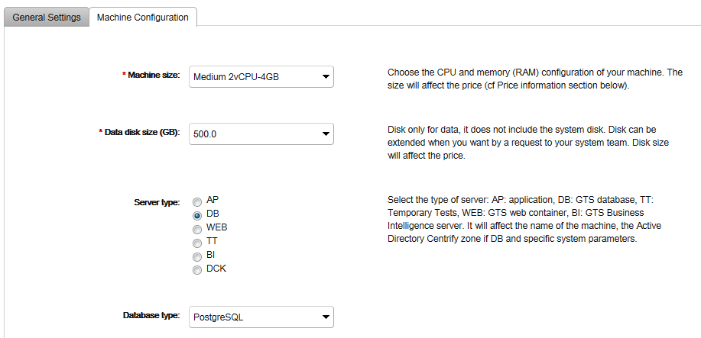

# Post installation of a PostgreSQL envirnonment

## Get the connection string of your new PostgreSQL Server

**Contact the DBA team:**  PAR-Resg-Gts-Mkt-Gdi-Postgresql

or

**ITAAS API call** (Coming soon)

## Create a user on the PostgreSQL Server

**Contact the DBA team:**  PAR-Resg-Gts-Mkt-Gdi-Postgresql

or

**PuppetAsAService call** (Starting from november 2016)

or

**ITAAS API call** (Coming soon)

## Create a database on the PostgreSQL Server

**Contact the DBA team:**  PAR-Resg-Gts-Mkt-Gdi-Postgresql

or

**PuppetAsAService call** (Starting from november 2016)

or

ITAAS API call (Coming soon)

## Setup your PostgreSQL backup policy

**Contact the DBA team:**  PAR-Resg-Gts-Mkt-Gdi-Postgresql

or

**ITAAS API call** (Coming soon)